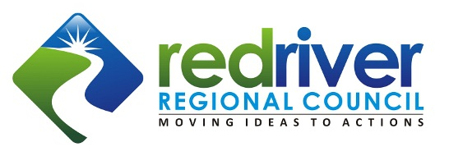
Ideas to Actions Summit Awards – Nomination Form

October 1, 2018 Deadline!

Summary

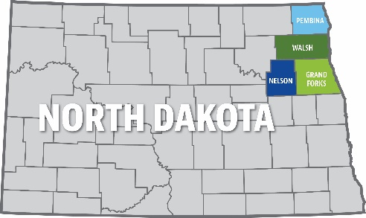
Creating positive community momentum and change requires vision, dedication, collaboration and stamina. Each year, Red River Regional Council (RRRC) recognizes great ideas, great leaders and great projects from throughout Grand Forks, Nelson, Pembina and Walsh Counties by soliciting nominations and selecting award winners to be recognized at the annual Ideas to Actions Summit. The RRRC is soliciting award nominations for three awards including North Star, Catalyst and Collaboration.

Considerations

- Nominees need NOT be affiliated with the RRRC.
- Self-nominations will be accepted.
- The nomination must be accompanied with a cover letter.
- People nominated for leadership/actions should still be active and have achieved significant success within the last five years.
- Projects should be nearly 50% completed as of the date of the nomination or have been completed in the last five years.
- The RRRC Board of Directors, with representation from all four counties, reviews all nominations and selects the award recipients.
- All nominees are recognized as “Community Builders” at the Summit.

Important Dates

- October 1, 2018 – Nomination deadline.
- November 13, 2018 – Awards Ceremony at the 4th Annual Ideas to Actions Summit at the Minto Community Center in Minto, ND.

AWARD CATEGORIES

North Star Award: The award for great ideas!
This award recognizes ideas that illuminate opportunities or create a guiding light for progress within a community.

Criteria: Recognizes a business, individual, or organization that:
1) has a clear vision;
2) sets a high standard for thinking outside of the box; and
3) has demonstrated success in moving their innovative and important idea(s) forward, i.e. a project, action, or event that demonstrated visionary, creative, impactful results and occurred within the award timeline.

Catalyst Award: The award for great leaders!

This award recognizes an individual who acts as a “Kickstarter” for an idea or project.

Criteria: Recognizes leadership action initiated by an individual who
1) had a significant impact on a community project or regional need;
2) brought others into the project (taking people with you); and
3) showed a significant level of personal commitment to the idea or project. This person can be an elected official, employee or a community-minded person.

Collaboration Award: The award for great projects!

This award recognizes successful projects that involve teamwork and create a notable impact.

Criteria: Recognizes successful projects that
1) shepherded an idea and moved it to an action phase;
2) the project had a notable impact on a community or regional need; and
3) were responsive to strategic actions identified by the community.

The following form is made to be fillable in MSWord. You can also submit the required form information and accompanying documentation in any format available to you. If you use the fillable document in MSWord, click in the enter text box and it will automatically scroll down and fill.

NOMINATION FORM

Information about the Nominee
NameClick here to enter text.
OrganizationClick here to enter text.
AddressClick here to enter text.
City/State/ZipClick here to enter text.
Phone Numbers (W/C)Click here to enter text.
EmailClick here to enter text.
WebsiteClick here to enter text.
Submitted by (if different than above)Click here to enter text.
Phone Numbers (W/C)Click here to enter text.
EmailClick here to enter text.
☐ I would like to remain anonymous.

Award Category for this nomination (check one)

☐North Star Award
☐Catalyst Award
☐Collaboration Award

Please use the space below to address each of the three criteria noted for the applicable award. Use examples, details, photos, data, etc. to best represent the project or person nominated. Attach additional sheets if necessary.
Click here to enter text.

Submit a cover letter to the narrative introducing the nomination to the executive committee of the RRRC and a photo(s) of the nominee and/or project.

Submit an electronic photo(s) of the person or project being nominated.

Submit the nomination form, cover letter and photo(s) on or before October 1, 2018 via email to cheryl@redriverrc.com or by mail to: Red River Regional Council, 516 Cooper Ave, Suite 101,
Grafton ND 58237

